CERTIFICATE OF ATTENDANCE

Attendee Name:

Outline of 2019 Changes to New York Medicaid SGD Guidelines
Wednesday, July 24 20197:00-8:00
Presented by Lewis Golinker, Advocacy Director USSAAC

This webinar included 1 hour of instruction in related subject matter
for speech-language pathologists. .1 hours earned

This certificate neither awards ASHA CEUs nor verifies that
ASHA CEUs have been awarded to the person named above.

ASHA CEUs are awarded by the ASHA CE Registry upon receipt of the CEU Participant Form from
the ASHA Approved CE Provider, USSAAC

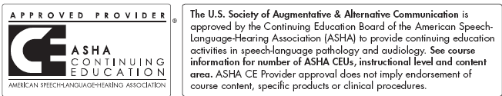.
If you have questions about this certificate, please contact smeehan8@ku.edu.

