CERTIFICATE OF ATTENDANCE

Attendee Name:

My Story of How Getting A Speech Device
Changed My Life
October 16, 2019

This webinar included 1 hour of instruction in professional subject matter
for speech-language pathologists. .1 hours earned

This certificate neither awards ASHA CEUs nor verifies that
ASHA CEUs have been awarded to the person named above.

ASHA CEUs are awarded by the ASHA CE Registry upon receipt of the CEU Participant Form from
the ASHA Approved CE Provider, USSAAC

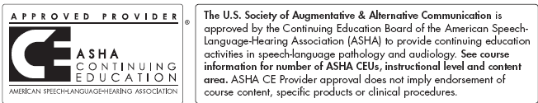.
If you have questions about this certificate, please contact smeehan8@ku.edu.

