CERTIFICATE OF ATTENDANCE

Attendee Name:

Patient-Provider Communication in the Time of COVID-19: Tips from the Frontlines
4/29/20

This webinar included 1 hour of instruction in professional subject matter
for speech-language pathologists. .1 hours earned

This certificate neither awards ASHA CEUs nor verifies that
ASHA CEUs have been awarded to the person named above.

ASHA CEUs are awarded by the ASHA CE Registry upon receipt of the CEU Participant Form from
the ASHA Approved CE Provider, USSAAC

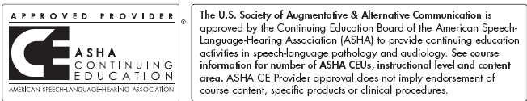.
If you have questions about this certificate, please contact smeehan8@ku.edu.

